Quiz application programs from my machine

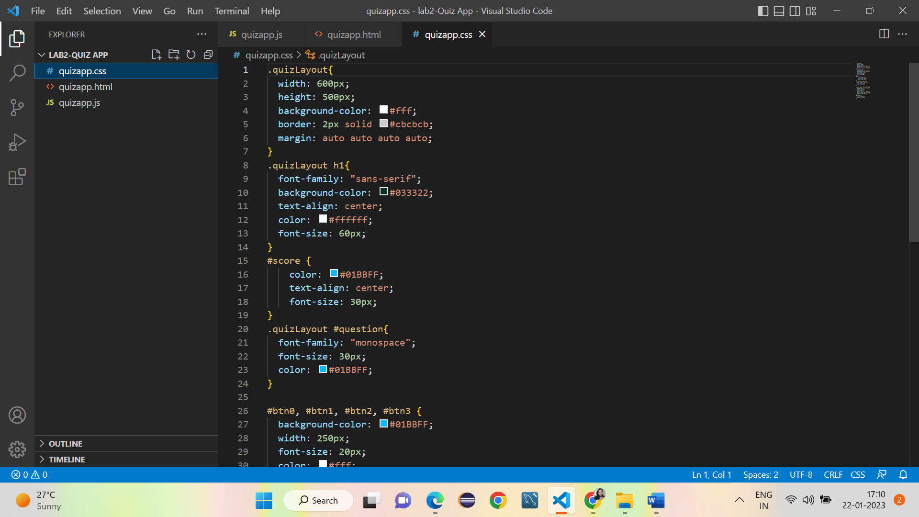

Execution of the quiz application

